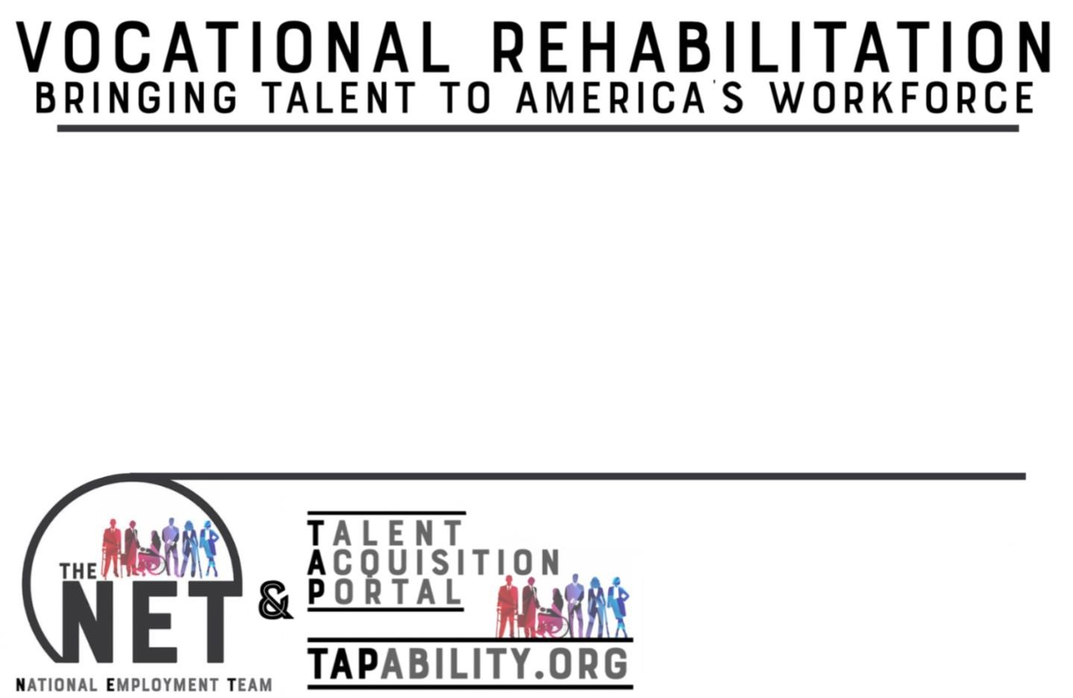

*The NET Services to Business*



Pre

-

Employment



Recruitment and Retention



Disability Awareness

Training



Employment Law

Education



Consultation and Support



Financial Advisement



Employee Assistance



Access to VR support at all levels

*Talent*

*Acquisition Portal*

***®***

*Features*



Job Posting and Metrics



Geographic Specific Resume Searches



Candidate Availability



Recruiter Access and Saved Searches



Compliance and Application Reports



Hiring Data



Interview Capability with Transcripts



Direct Access to VR

Agencies

*TAP is Supported by

The

NET

Get Started Today!

**Contact**

**:**

*Kathy West*

*-*

*Evans*

-

Director of Business Relations

kwest

-

evans@csavr.org

*Inger*

*Neal*

–

Business Relations Consultant

ineal@csavr.org