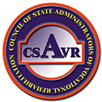
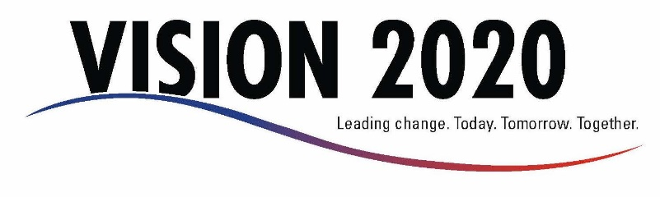

Council of State Administrators of Vocational Rehabilitation (CSAVR) is pleased to announce our 2017 Fall Conference to be held in Greenville, SC, on November 13-15, 2017. CSAVR invites submissions of proposals from practitioners, rehabilitation educators, and other professionals working in the field of rehabilitation.

Content Areas of Presentation

CSAVR’s fall conference will focus on State Agencies progress in implementing WIOA. We are seeking proposals for presentation that focus on several specific areas of WIOA in which there is considerable interest to our members, Hill staff, core partners, other state and federal agencies and members of the disability community at large. We anticipate that we will have space on the conference agenda for presentations at two General Sessions and 5-6 concurrent sessions. With that in mind, proposals will be considered on a first come, first serve basis, based on their merit.

Proposals will be accepted for general and concurrent presentations. Submissions may represent the following content areas:

- Business Engagement, including any new business partners or partnerships that you have developed through the NET and successes you have achieved as a result of utilization of the Talent Acquisition Portal (TAP). This includes examples of cross state partnerships supported by the NET.
- Data Sharing – highlighting your process to do this with core partners and the value to VR.
- Customized employment – Utilization of this placement strategy and outcomes or expected outcomes.
- MOUs with core partners and the benefits to VR in their establishment and utilization.
- Pre-ETS – Numbers served and any outcomes achieved.
- Section 511 – Strategies for implementation and any successes you have achieved.
- Career pathways or apprenticeship programs you have partnered with others to develop.
- Strategies used to successfully meet the expanded supported employment requirements,
- Customer services strategies that your agency has implemented to more efficiently serve customers with disabilities.

We encourage the inclusion of any partners you identify in your presentations at the fall conference. Time and space permitting, we would also consider other special projects in which you are engaged that have increased or have the potential to increase employment outcomes for individuals with disabilities.

The deadline for submitting proposals is close of business, Monday, July 31, 2017.

Send proposals to Rita Martin at rmartin@rehabnetwork.org John Connelly at jconnelly@rehabnetwork.org. Please place “CSAVR 2017 Proposal” in the subject line of your email.

Proposal Submission

Please provide all information as requested. Proposals to be submitted as an email attachment.

Presentation Title: Type Title Here
(limited to 80 characters)

Content Area from List Above: Content Area

Lead Presenter: Name & Title

Agency/Organization: Agency/Organization

Email: Email

Phone: Phone Number

Co-Presenter 1: Name & Title

Agency/Organization: Agency/Organization

Email: Email

Phone: Phone Number

Co-Presenter 2: Name & Title

Agency/Organization: Agency/Organization

Email: Email

Phone: Phone Number

If more than 2 co-presenters please attach on a separate page with required information.

Abstract: Length of content description should not exceed 500 words. Be as concise as possible and describe learning objectives, target audience, and lecture or group participation.
Abstract

Session Format: Lecture Lecture & Small Group Discussion Facilitated Discussion

Audiovisual Equipment Request: AV Equipment (Projector, Laptop, Screen, etc.)

My PowerPoint Presentation will contain videos. Yes

My Presentation will need internet connection. Yes

By checking this box, you agree to provide presentation materials by October 30, 2017 to enable accessibility of materials for attendees. I agree. Email materials to thamrick@rehabnetwork.org.

