CSAVR Virtual Fall Conference
November 9-13th 2020

100th Anniversary Celebration of the VR Program

Monday, Nov. 9, 2020
1:00 p.m. – 4:15 p.m.

First General Session
1:00 p.m.-1:05 p.m.

Welcome Remarks: (5 minutes)
Allison Flanagan, President, CSAVR
State Director, Florida General

1:05 p.m.-1:25 p.m. (20 minutes)

Steve Wooderson CEO, CSAVR,
Recognition of New State Directors and CEO Update

1:25 p.m-1:30 p.m. – 5 - minute break

1:30 p.m. - 2:15 p.m. (45 minutes)

Celebrating 100 years of Vocational Rehabilitation,1920-2020
Past, Present and Future

Mark Schultz, Acting Assistant Secretary,
Office of Special Education and Rehabilitative Services (OSERS)
Commissionner, Rehabilitation Services Administration (RSA)

2 :15 p.m. – 2:30 - 15- minute break

2:30 p.m. – 3:10 p.m. (40 minutes)

Implicit Bias in Mental Health

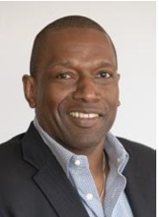
Victor Armstrong joined North Carolina DHHS as Director of the NC Division of Mental Health, Developmental Disabilities, Substance Abuse Services in March of 2020, with responsibility and oversight of the public community-based mental health, intellectual and other developmental disabilities, substance use, and traumatic brain injury system in North Carolina. Prior to accepting this role, Victor spent six years as Vice President of Behavioral Health with Atrium Health. Based in Charlotte, NC Victor had responsibility for operations of Atrium’s largest behavioral health hospital, Behavioral Health Charlotte (BHC). Victor has over 30 years of experience in human services, primarily dedicated to building and strengthening community resources to serve individuals living with mental illness. ‬‬‬‬‬‬‬

Victor currently serves on the board of directors of American Foundation for Suicide Prevention (AFSP) NC. He is also former board chair of NAMI NC, and a member of American Association of Suicidology (AAS), and NASW-NC. Victor is a former member of the Board of Directors of National Council for Behavioral Health, i2i Center for Integrative Health, and RI International.

Victor’s awards and recognitions include 2019 Black Mental Health Symposium -Mental Health Advocate of the Year, 2019 Atrium Health Excellence in Diversity & Inclusion Award, 2018 Distinguished Alumni Award from East Carolina University School of Social Work, Pride Magazine 2018 "Best of the Best", and i2i Center for Integrative Health 2018 Innovation Award for "Whole Person Care", 2012 National Alliance on Mental Illness (NAMI) NC, Mental Health Professional of the Year.

Victor graduated, Magna Cum Laude, from North Carolina Central; University with a bachelor’s degree in Business Management and received a Master of Social Work (MSW) from East Carolina University. He is the husband of Dr. Charletta Armstrong and the father of 3 sons, Carter, Alonzo, and Victor Jr.

3:10 p.m.-3:25 p.m.–

CSAVR Response/Plan of Action to address Victor’s Presentation (15 minutes)

TBD - Who will deliver CSAVR Response

3:25 p.m.- 3:30 p.m. 5 -minute break

3:30 p.m. – 4:15 p.m. (45 minutes)

Title TBD
Darrell “Coach” Andrews –
Shannon Austin, State Director, PA Combined

Darrell "Coach D" Andrews is a nationally acclaimed education and workforce development consultant, motivator and strategist. He is the author of the books Believing The HYPE-Seven Keys to Motivating Students of Color, The Purpose Living Teen-A Teens Guide To Living Your Dreams, The Parent As Coach-Developing A Family Dream Team and Reinvention-The Pathway To Job Search Success. For the past two decades, He and his team of strategists and motivators have helped state agencies, organizations, schools, and non-profits develop motivational systems that positively impact youth and adult job seekers and staff in Workforce Development and Vocational Rehabilitation.

His company, Darrell Andrews Enterprises, is becoming a national influence in the arena of equity motivation in the workforce and government agency space. He and his team firmly believe that equity is a heart issue, not a head issue. Diversity is not a program, it is a values-based personal and organizational decision.

DAE is also a channel partner with Fit-First Technology where they are a USA representative of Fit First's Technology "Jobtimize." Jobtimize is an Artificial Intelligence-driven technology designed to help all job seekers identify personal behaviors and assets that can lead to new employment possibilities.

Lastly and most importantly, he has been happily married for 26 years and is the proud father of Darrell Jr, Sophia, Alexander, and Abigail. His family is his pride and joy.

Adjourn 4:15 p.m.

---------------------------------------------------------------------------------------------------

Tuesday, Nov.10th, 2020
1:00 p.m. – 4:00 p.m.

Second General Session
I:00 p.m. – 1:40 p.m.

Discretionary Grant Update (session to be pre-recorded)

RSA staff will describe its newly awarded discretionary grants and how they will support the future progress of the VR program and professionals in the field.

Who will present here?

I:40 p.m. – 1:45 p.m. - 5- minute break

1:45 p.m. – 2:30 p.m. - Ask RSA

RSA staff will be available to respond to questions from conference attendees during an informal chat.

Who will present here?

2:30 p.m. – 2:40 p.m. – 10- minute break

2:40 p.m.- 3:25 p.m. (45 -minute session – to be pre-recorded)

Other Measures that Matter

Members of the Rehab Data Work Group will share its work in developing the “other measures that matter” and data analysis tools to support data-informed decision making at the Federal and State levels.

Rachel Anderson, WINTAC (rcanderson@sdsu.edu)
Bill Colombo, Michigan Rehabilitation Services (MI-G)
Scott Dennis, Maryland Division of Rehabilitation Services (MD-C)
Natasha Jerde, Minnesota State Services for the Blind (MN-B)
Adam Leonard, Texas Workforce Commission
Kristen Mackey, Arizona Rehabilitation Services Administration (AZ-C)
Suzanne Mitchell (need title)
Chris Pope (meed title)
3:25 p.m.- 3:35 p.m. (10 -minute break)
3:35 p.m. 4:15 p.m. - The Future of Monitoring (45 minutes – to be pre-recorded)

Members of the Monitoring Work Group will describe its recommendations for a revised VR program monitoring protocol that is meaningful and beneficial to RSA and VR agencies and fosters quality employment outcomes for individuals with disabilities.

David Doukas, State Director, CT-G
Dacia Johnson, State Director, OR-B
Delora Newton, State Director, WI-C
William Robinson, State Director, MI-B
Cheryl Fuller, State Director, TX-C
Eric Weiss, State Director, SD-G

Carol Dobak (need titles for all presenters)
Suzanne Mitchell
RoseAnn Ashby
David Steele
Tonya Stellar
Jim Doyle
Joe Doney
Mary Williams

Adjourn 4:15 p.m.

4:30 p.m. – 5:30 p.m. - Virtual Happy Hour
Please pour your favorite cocktail and join us for a Virtual Happy Hour – A little camaraderie and laughter as we maneuver troubled waters.
------------------------------------------------------------------------------------------------
Wednesday, Nov. 11
1:00 p.m. – 4:00 p.m.

Third General Session
1:00 p.m. – 2:00 p.m.

A Salute to and Recognition of Veterans

Introduction of Speaker – Rob Hines, State Director, Washington General
Chair: Veterans Professional Network
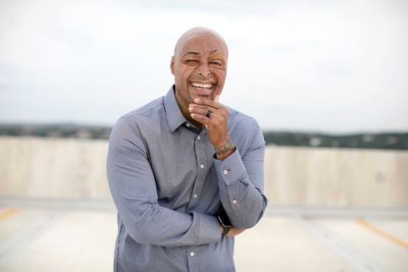
J.R. Martinez is an Army veteran, burn survivor, actor, motivational speaker, New York Times best-selling author and Dancing with the Stars season 13 winner.
J.R has traveled the world speaking with troops at various bases, as well as serving as keynote speaker for numerous major corporate events, non-profits, Universities and Fortune 500 companies.
J.R. devotes himself to spreading his message of resilience and optimism.

2:00 p.m. – 2:10 p.m.– 10 -minute break

2:10 p.m. - 2:50 p.m. – 40 minutes
Introduction of Speaker: TBD

VR&E AND VR – Partnership Serving Mutual Customers

Will) Streitberger. Director, VR&E -
Additional Presenters TBD

2:50 p.m.-3:00 p.m. – 10 -minute break

3:00 p.m. -3:15 p.m. (15 minutes) Recognition of CSAVR Veterans

Rob Hines, State Director, Washington General

3:15 p.m. Adjourn for the Day

-----------------------------------------------------------------------------------------------
Thursday, Nov. 12th
1:00 p.m.-4:00 p.m.

Fourth General Session –

1:00 p.m. -2:00 p.m.
CVS Initiative on Diversity and Inclusion in Hiring Practices
CVS Video

2:00 p.m.-2:10 p.m.- 10 -minute break

2:10 p.m.- 3:10 p.m.

VR/IPS Services Coordination – session to be pre-recorded
Presenters:

Bob Drake, M.D, PhD
Vice President
The IPS Employment Center at the
Rockville Institute

Gene Oulvey, PhD.
Coordinator, Psychiatric Rehabilitation Services
Illinois Department of Human Services
Division of Vocational Rehabilitation
Lee Ann Reinert, LCSW
Deputy Director
Policy, Planning and Innovation
Illinois Department of Human Services
Division of Mental Health

Darius McKinney
IPS Program Manager
Illinois Department of Human Services
Division of Mental Health
Rachel Hoard, MA
Behavioral Health Supported Employment Coordinator/Trainer
Division of Vocational Rehabilitation
Colorado Department of Labor and Employment

Patricia Henke, MS, CRC
Director
Colorado Office of Employment First

Alia Andrews
Recovery Services Coordinator
Adult Treatment and Recovery Programs
Colorado Office of Behavioral Health

3:10 p.m. – 3:20 p.m. – 10- minute break

3:20 p.m.- 4:10 p.m. ( session to be pre-recorded )

Independent Living under WIOA and the Future for Collaboration

Staff from the Department of Health and Human Services, Administration on Community Living will describe changes to independent living programs since enactment of the Workforce Innovation and Opportunity Act and join with RSA staff in describing their collaboration promoting partnerships among VR agencies, CILs, and special education in the States that support competitive integrated employment for students, youth, and young adults with disabilities.

4:10 p.m. Adjourn

-------------------------------------------------------------------------------------------------
Friday, November 13th, 2020
1:00 p.m.-4:30 p.m.

FIFTH GENERAL SESSION
1:00 p.m. – 1:45 p.m.

Lessons from Fiscal Monitoring (45 minutes- session to be- pre-recorded)

RSA fiscal staff will present select fiscal findings from recent monitoring reports and discuss the issues raised and implications for VR agencies.

1:45 p.m. – 1:50 p.m. 5- minute break

1:50 p.m. – 2:50 p.m.

From CIA to Executive:
How Vocational Rehabilitation Set Me on The Path to Success

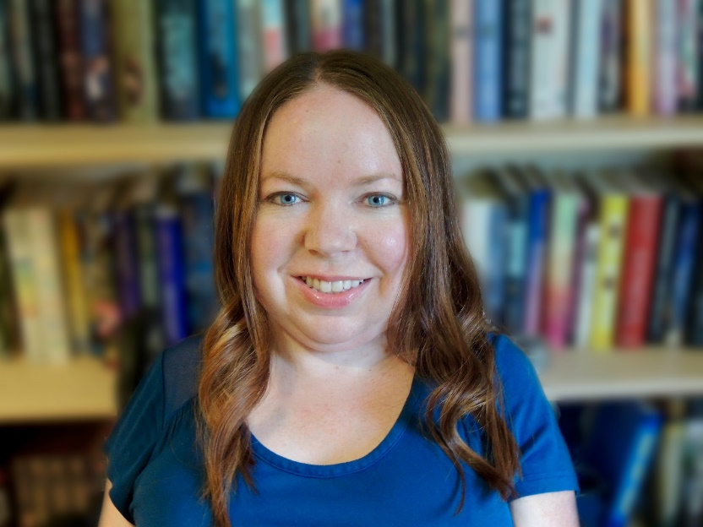
Cindy L. Otis is the Vice President of Analysis for Alethea Group, a disinformation investigations and remediation firm, and is an expert on disinformation threat analysis and counter messaging. She is also a Senior Non-Resident Fellow at the Atlantic Council’s Digital Forensic Research Lab and an Associate at Argonne National Lab. Prior to joining the private sector in 2017, she served in the CIA as a military analyst, intelligence briefer, and a manager in the Directorate of Intelligence. While at the CIA, she specialized in security issues in Europe, the Middle East, and North Africa. Otis is a frequent media commentator on national security, intelligence, and disinformation, and is a Member of USA Today's Board of Contributors. She is also the author of True or False: A CIA Analyst’s Guide to Identifying and Fighting Fake News.

2:50 p.m. -3:00 p.m. – 10- minute break

3:00 p.m.- 4:30 p.m.
CSAVR Business Meeting

Conference Adjourns 4:30 pm

